

**MALAYSIAN INSTITUTE OF INFORMATION TECHNOLOGY**

**OCTOBER 2025**

**IBB43203 – CLOUD COMPUTING**

**GROUP PROJECT ASSIGNMENT**

**PREPARED BY**

|  |  |  |  |
| --- | --- | --- | --- |
| **Name** | **ID** | **LAB** | **Course** |
| MUHAMMAD ASRI BIN AZIZAN | 52222122034 | L01-B01 | BCE |
| MUHAMAD KHAIRUL IKHWAN BIN SAMSUDIN | 52222122346 | L01-B01 | BCE |
| NUR MUNAWWARAH BINTI MUZAMIL | 52222122129 | L01-B01 | BCE |

**PREPARED FOR**

|  |  |
| --- | --- |
| **Lecturer** | MEGAT NORULAZMI MEGAT MOHAMED NOOR – ASSOC. PROF. DR. |

Table of Contents

TITLE 3

GITHUB AND VIDEO PRESENTATION 3

INTRODUCTION 3

OBJECTIVES 4

SYSTEM ARCHITECTURE 4

METHODOLOGY 4

STEP 0: Login and Set AWS Region 4

STEP 1: Create EC2 Instance 5

STEP 2: Install Web Server (Apache & PHP) 8

STEP 3: Create S3 Bucket (Storage) 9

STEP 4: Create DynamoDB Table (Database) 11

STEP 5: Create and Attach IAM Role 13

STEP 6: Networking Configuration 16

STEP 7: Deploy Website Files 16

STEP 8: Install AWS SDK for PHP 17

STEP 9: Access the Web Application 18

STEP 10: Verify Data in DynamoDB 20

RESULTS AND DISCUSSION 21

TEAM CONTRIBUTION 21

CONCLUSION 21

# TITLE

Group Project Assignment

# GITHUB AND VIDEO PRESENTATION

* Github repository: <https://github.com/asriazizan930-svg/cloud-computing-project-assignment>
* Youtube link: <https://youtu.be/NS-dTs1NuyI>

# INTRODUCTION

Cloud computing is now an important technology in modern information systems. It enables users and organizations to utilize computing resources like servers, storage, databases, and applications over the Internet without having to own or manage physical hardware. Utilizing cloud services allows organizations to reduce expenses and implement applications more effectively. Cloud computing is extensively utilized in education, commerce, and various other fields.

Amazon Web Services (AWS) is a widely used cloud platform. AWS offers a variety of on-demand cloud services that facilitate computing, storage, networking, and database administration. These services are adaptable and can be scaled up or down according to user needs. AWS enables students and beginners to explore and learn cloud technologies for little to no expense.

This project utilizes AWS to create and launch a basic web application. Amazon EC2 hosts the web server, Amazon S3 provides storage, and Amazon DynamoDB serves as the database. AWS Identity and Access Management (IAM) is utilized to guarantee safe communication between services. Completing this project provides hands-on experience in launching a cloud-based application and understanding how various AWS services collaborate in a real-world context.

# OBJECTIVES

1. To deploy a web application using AWS services.
2. To utilize AWS Compute, Storage, Networking, and Database services
3. To provide a clear, step-by-step guide that allows replication of the project.

# SYSTEM ARCHITECTURE

The AWS services used in this project are Amazon EC2 which hosts the apache web server and PHP application. Amazon S3 is used to provide cloud storage for project-related files. Amazon DynamoDB is used as the database for storing project records. AWS IAM is used to manage secure access between AWS services. Lastly, this project uses default VPC, security group and connectivity from the free tier setup.

The system architecture consists of a user accessing the web application through a browser. Requests are handled by an Apache web server running on an EC2 instance. Application data is stored in DynamoDB, while static files may be stored in an S3 bucket. IAM roles allow secure communication between EC2, DynamoDB, and S3.

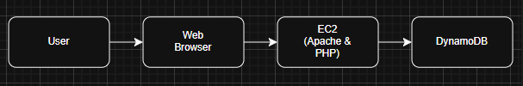

Figure 1 System architecture

# METHODOLOGY

## STEP 0: Login and Set AWS Region

1. Login to the AWS Management Console

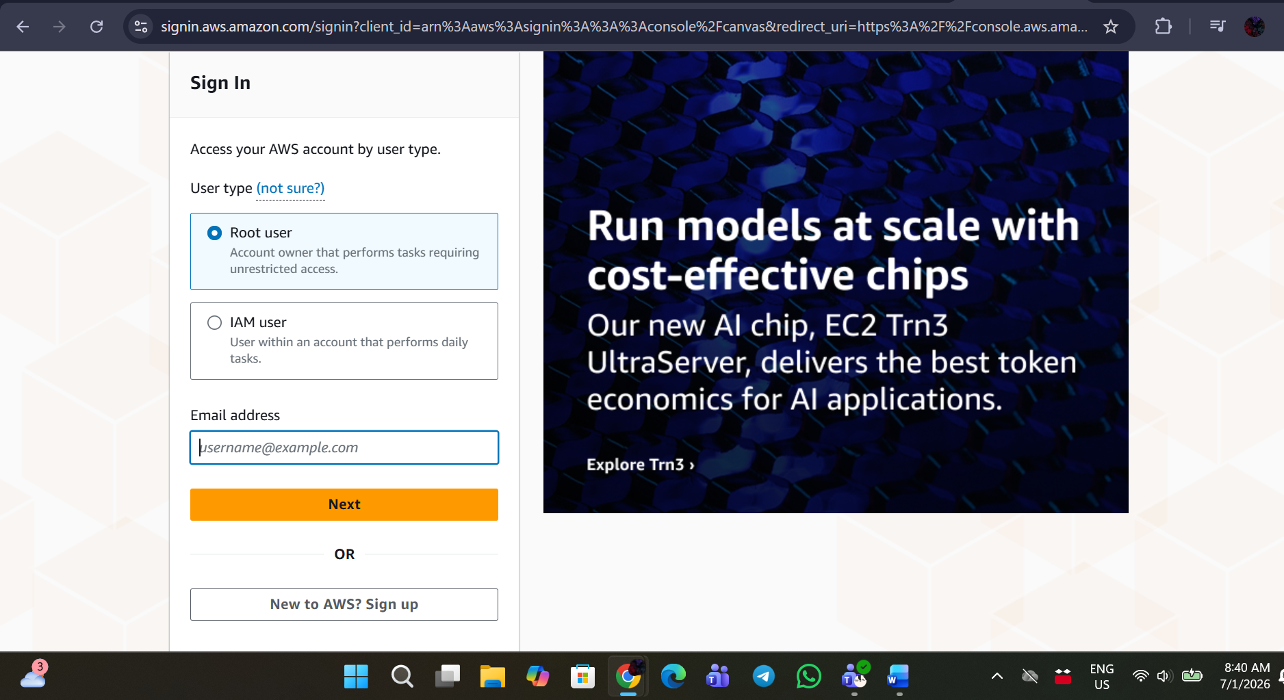

1. Set the Region to Asia Pacific (Singapore), ap-southeast-1.

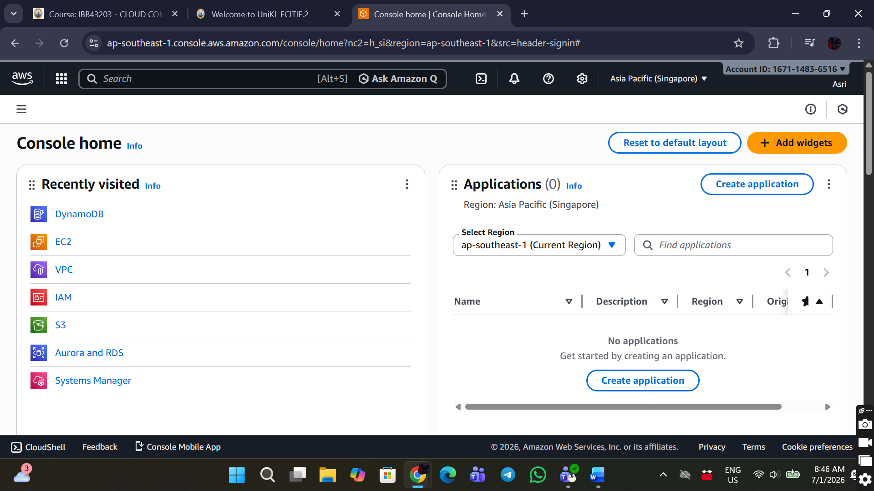

## STEP 1: Create EC2 Instance

1. Search EC2 in AWS Console

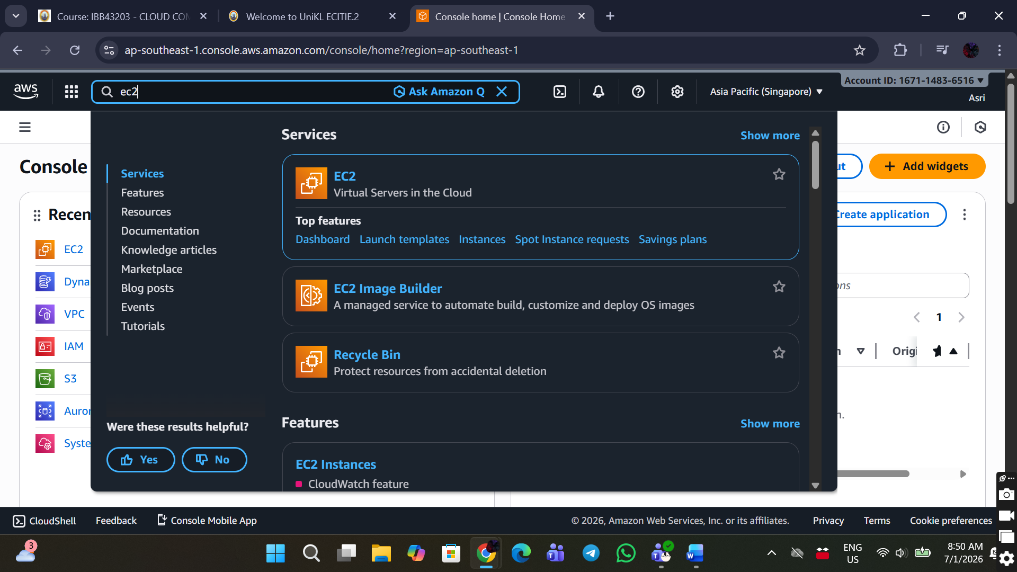

1. Click Launch instances

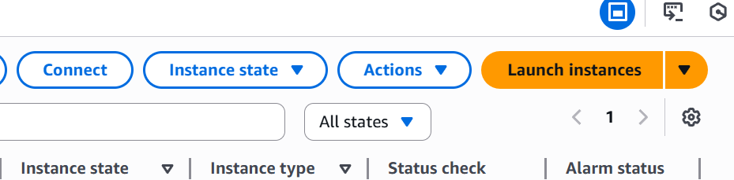

1. Configure Instance

* Name: project-assignment-ec2

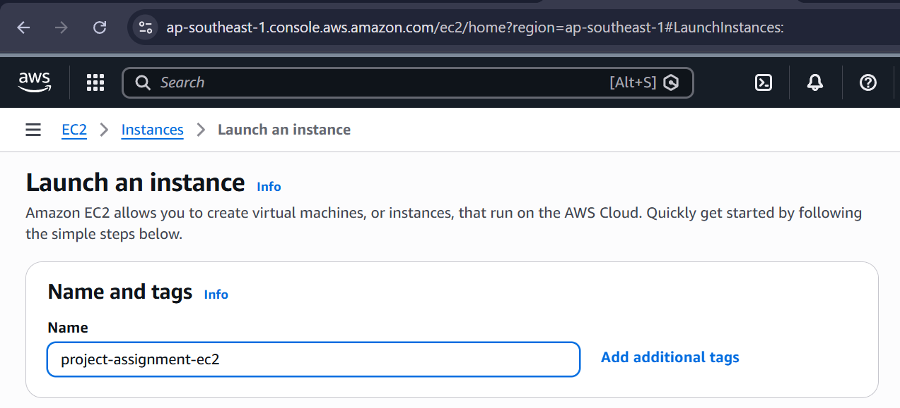

* AMI: Amazon Linux 2

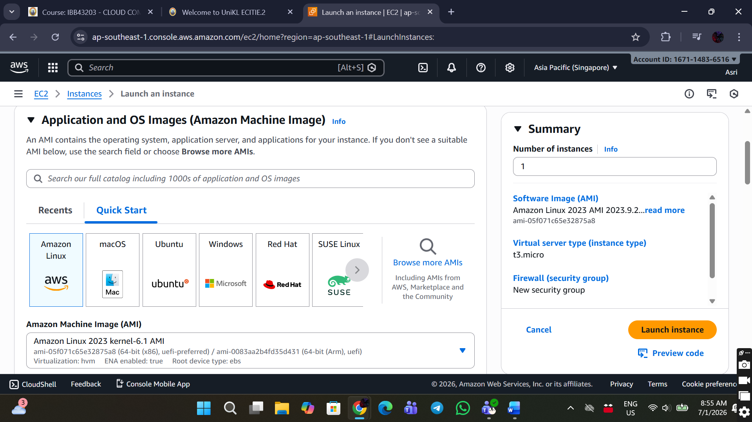

* Instance type: t3.micro
* Key pair: Create a new key pair and download it

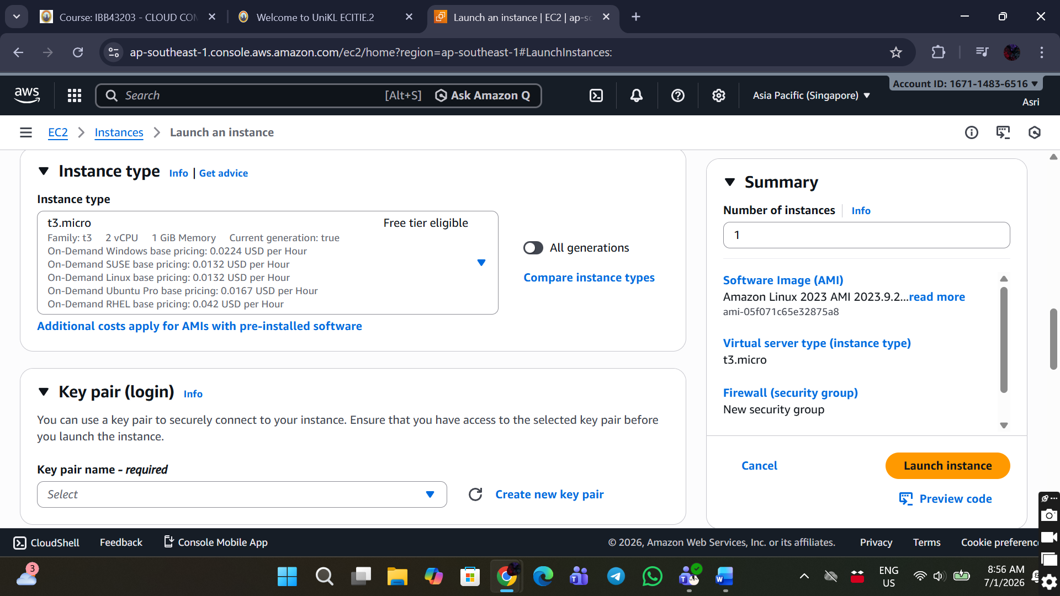

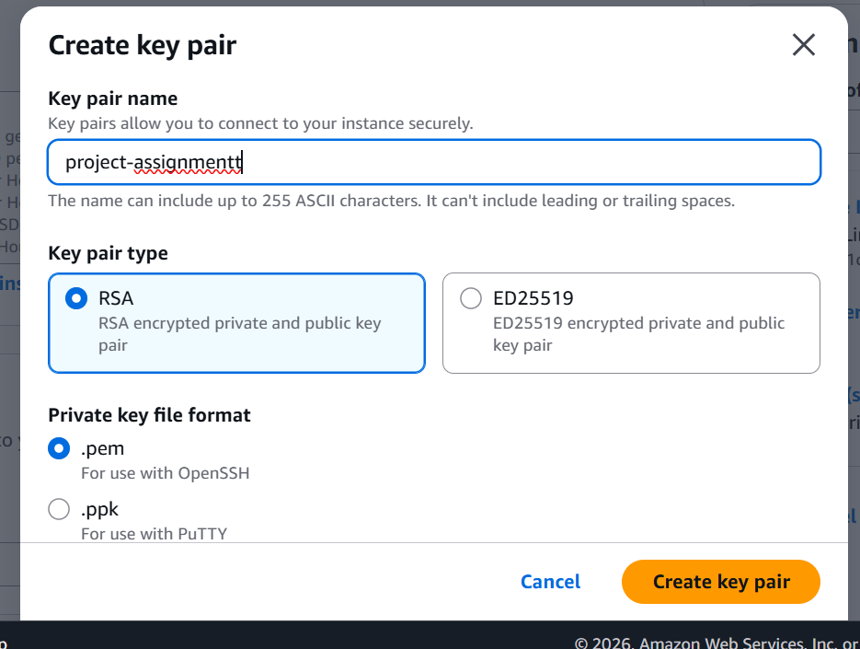

1. Network Settings

✅ Allow SSH traffic form (Port 22)

✅ Allow HTTP (Port 80)

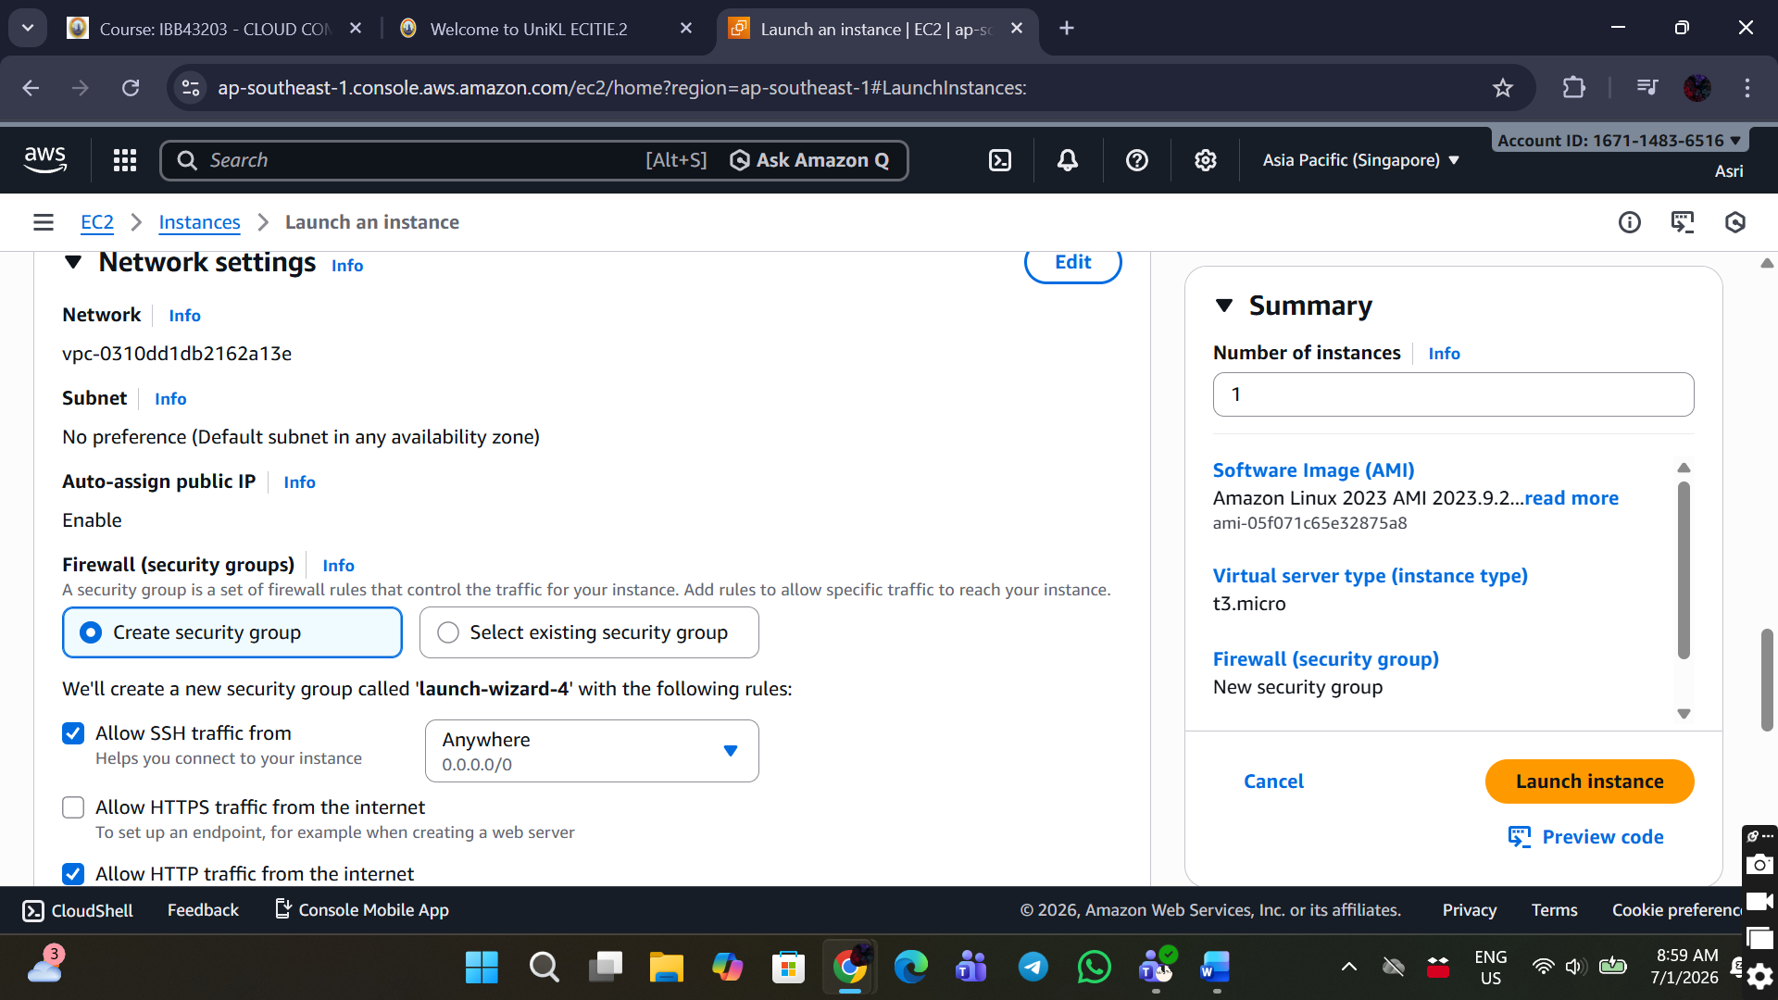

1. Click Launch instance at the bottom right corner.
2. Make sure the instance is running

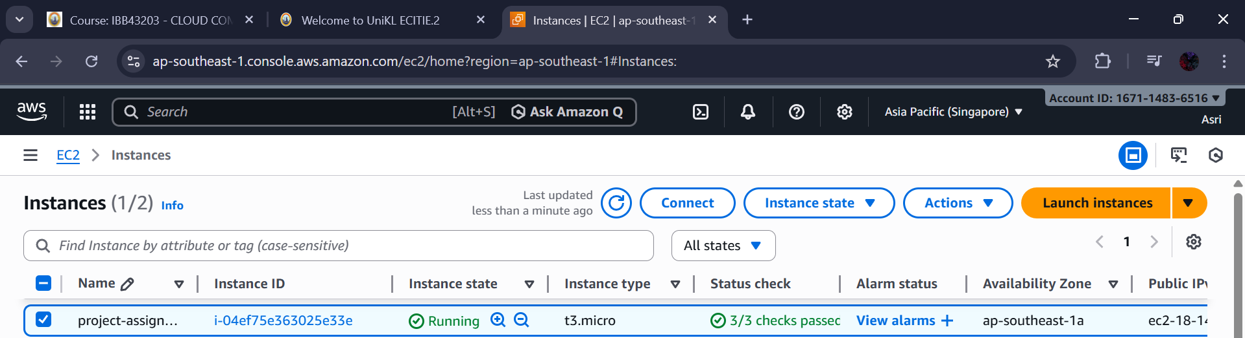

## STEP 2: Install Web Server (Apache & PHP)

1. Connect to EC2 using SSH, click the Connect button located besides the refresh button.

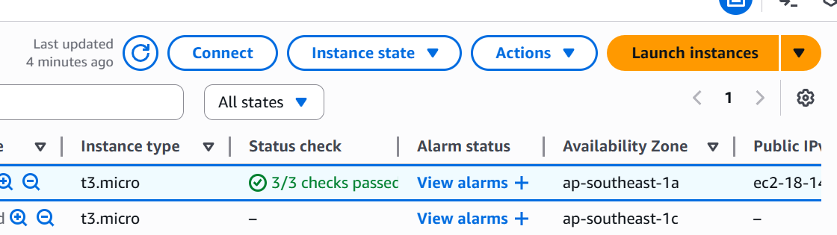

1. Run the following commands:

sudo yum update -y

sudo yum install httpd php -y

sudo systemctl start httpd

sudo systemctl enable httpd

1. Verify Apache status, must show active (running)

sudo systemctl status httpd

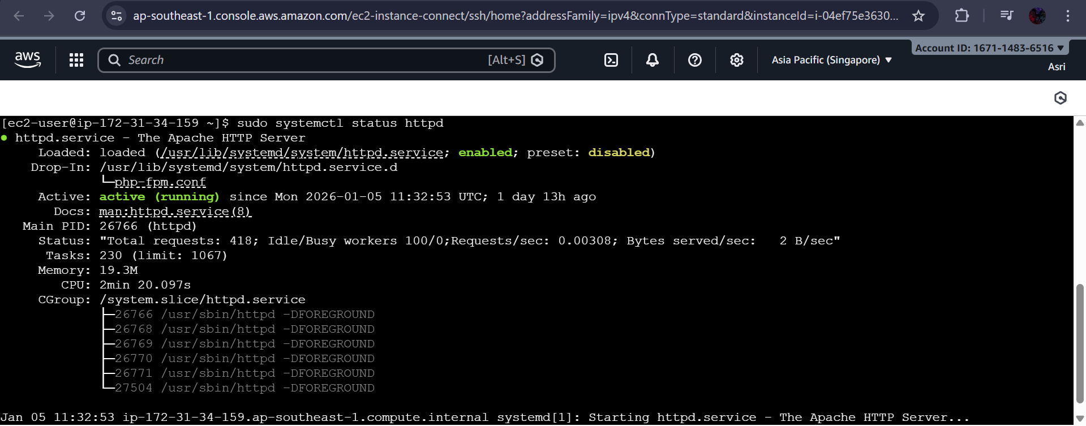

STEP 3: Create S3 Bucket (Storage)

1. Search S3
2. Click Create bucket

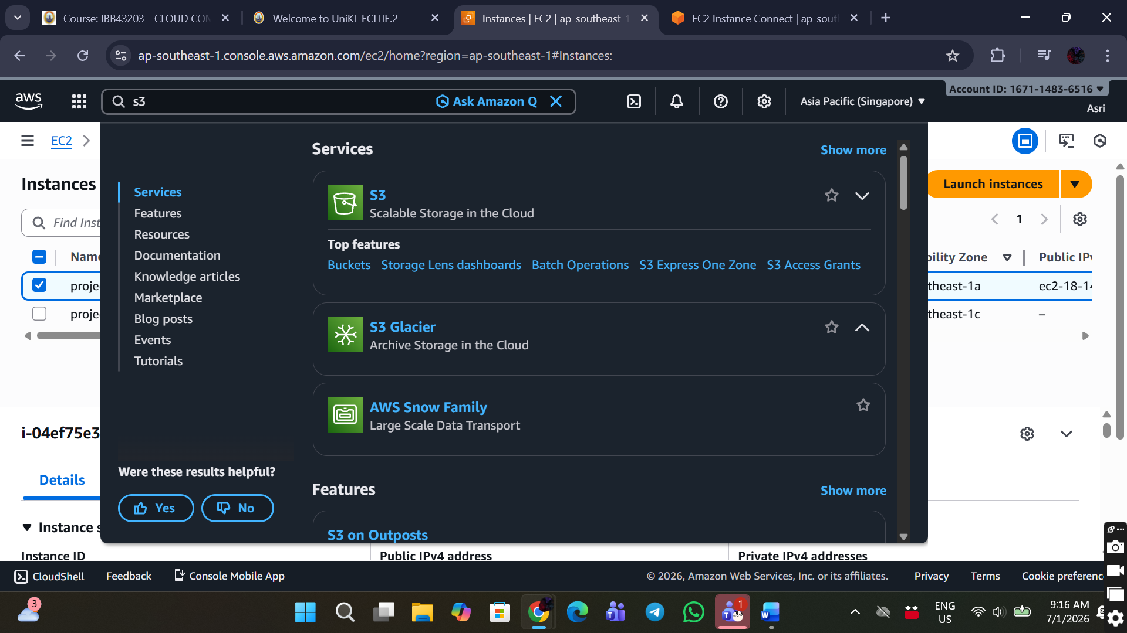

1. Bucket Configuration

* Bucket name: project-assignment-files-123
* Region: Asia Pacific (Singapore)

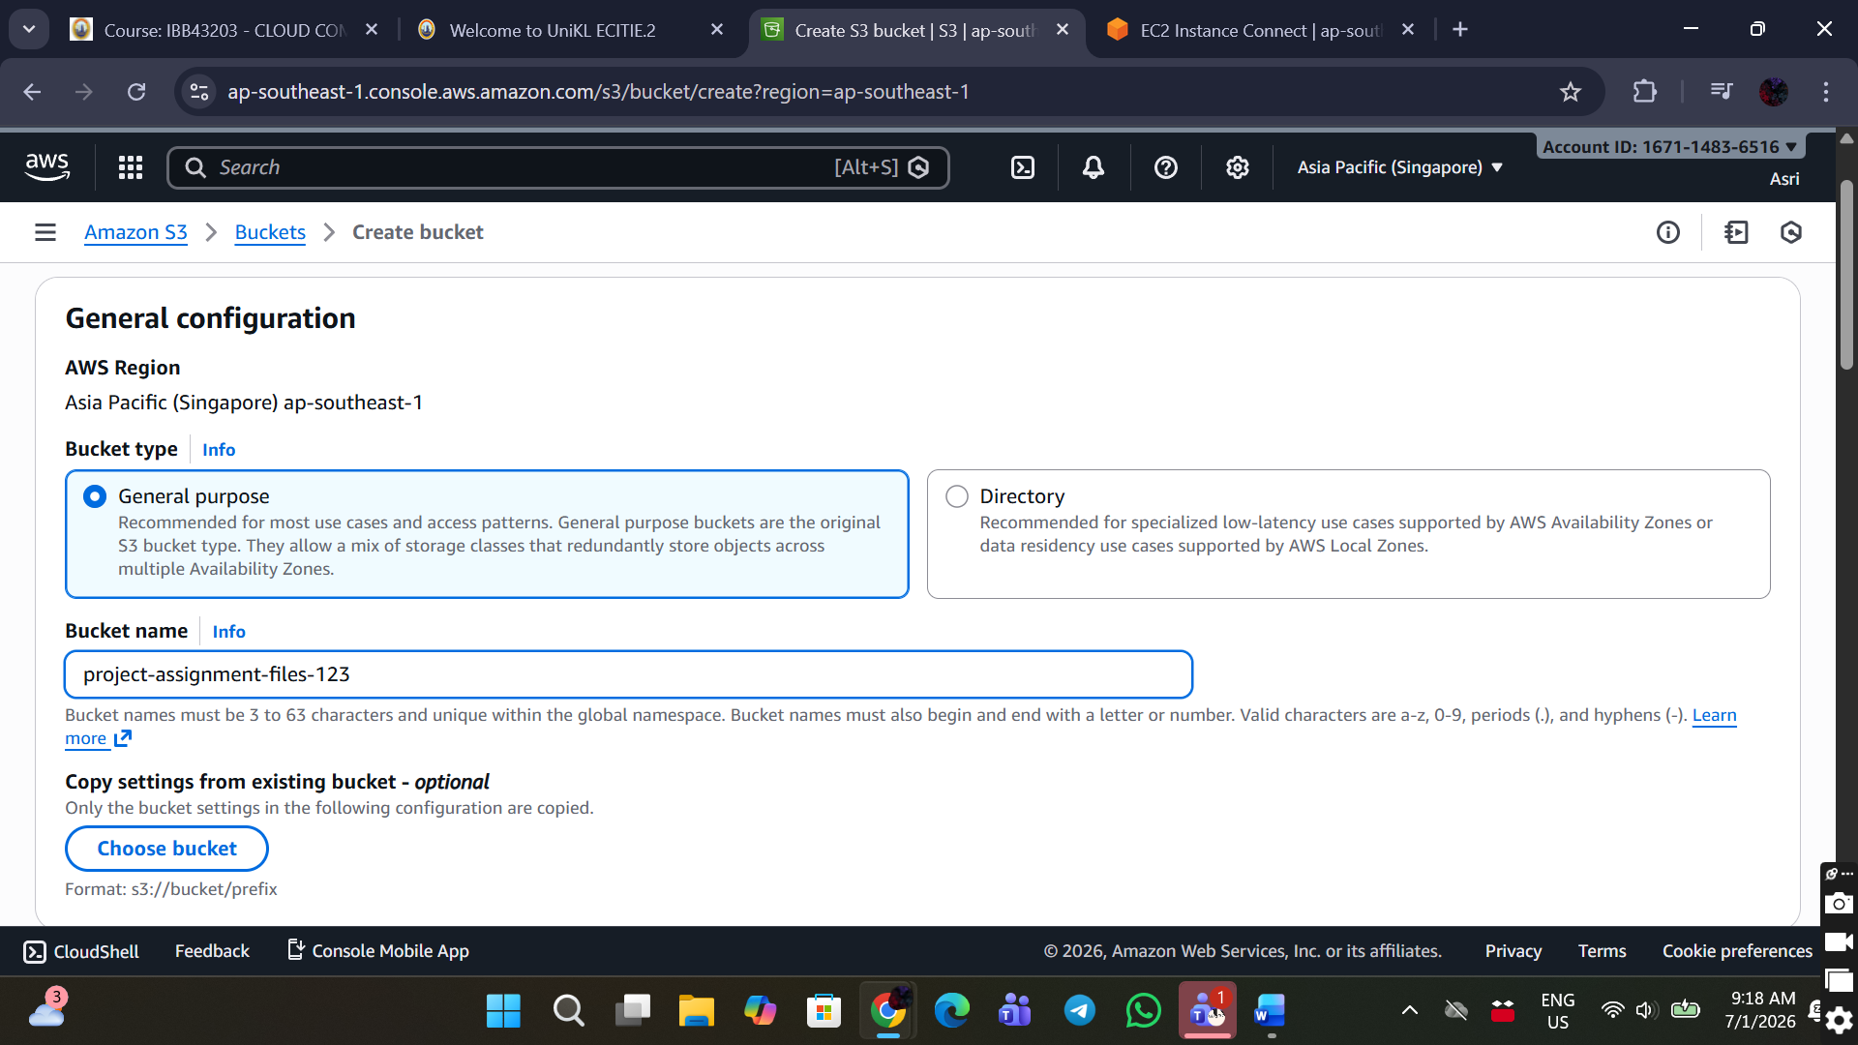

* Public access: Untick Block all public access

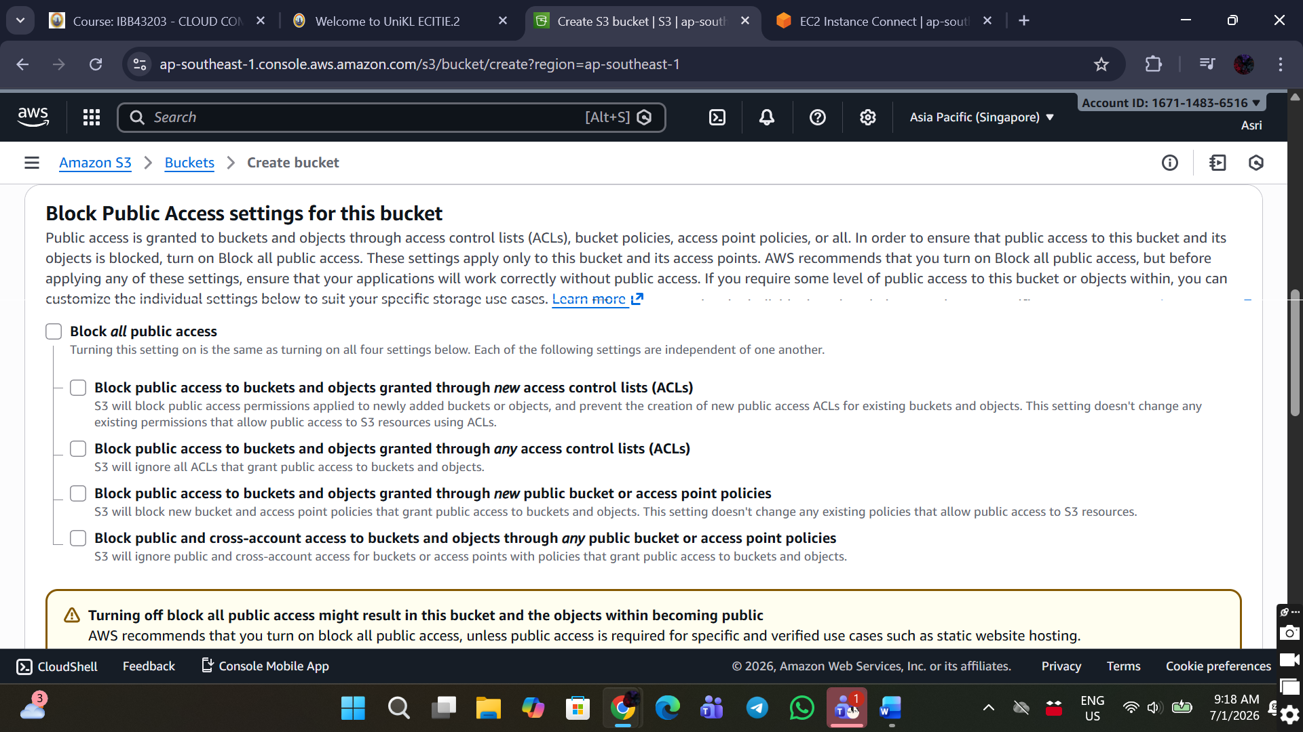

1. Click Create bucket, wait until the bucket is successfully created.

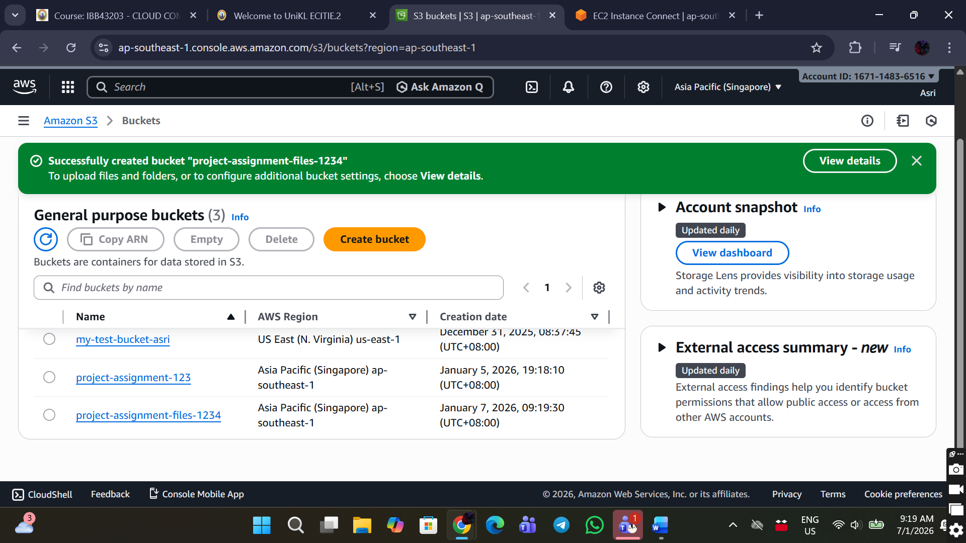

## STEP 4: Create DynamoDB Table (Database)

1. Search DynamoDB
2. Click Create table

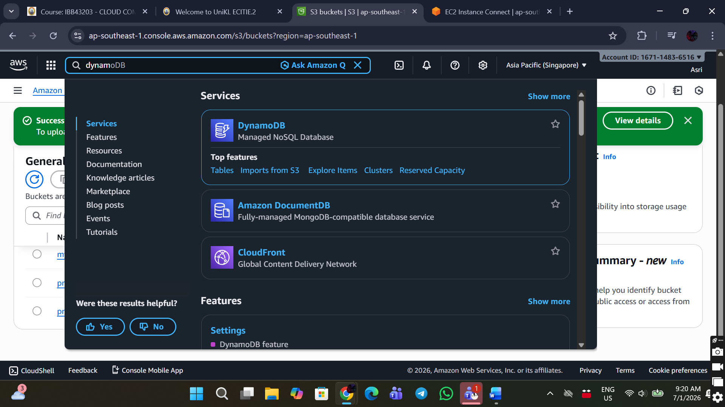

1. Table Configuration

* Table name: project-assignment-table
* Partition key: ProjectID (String)

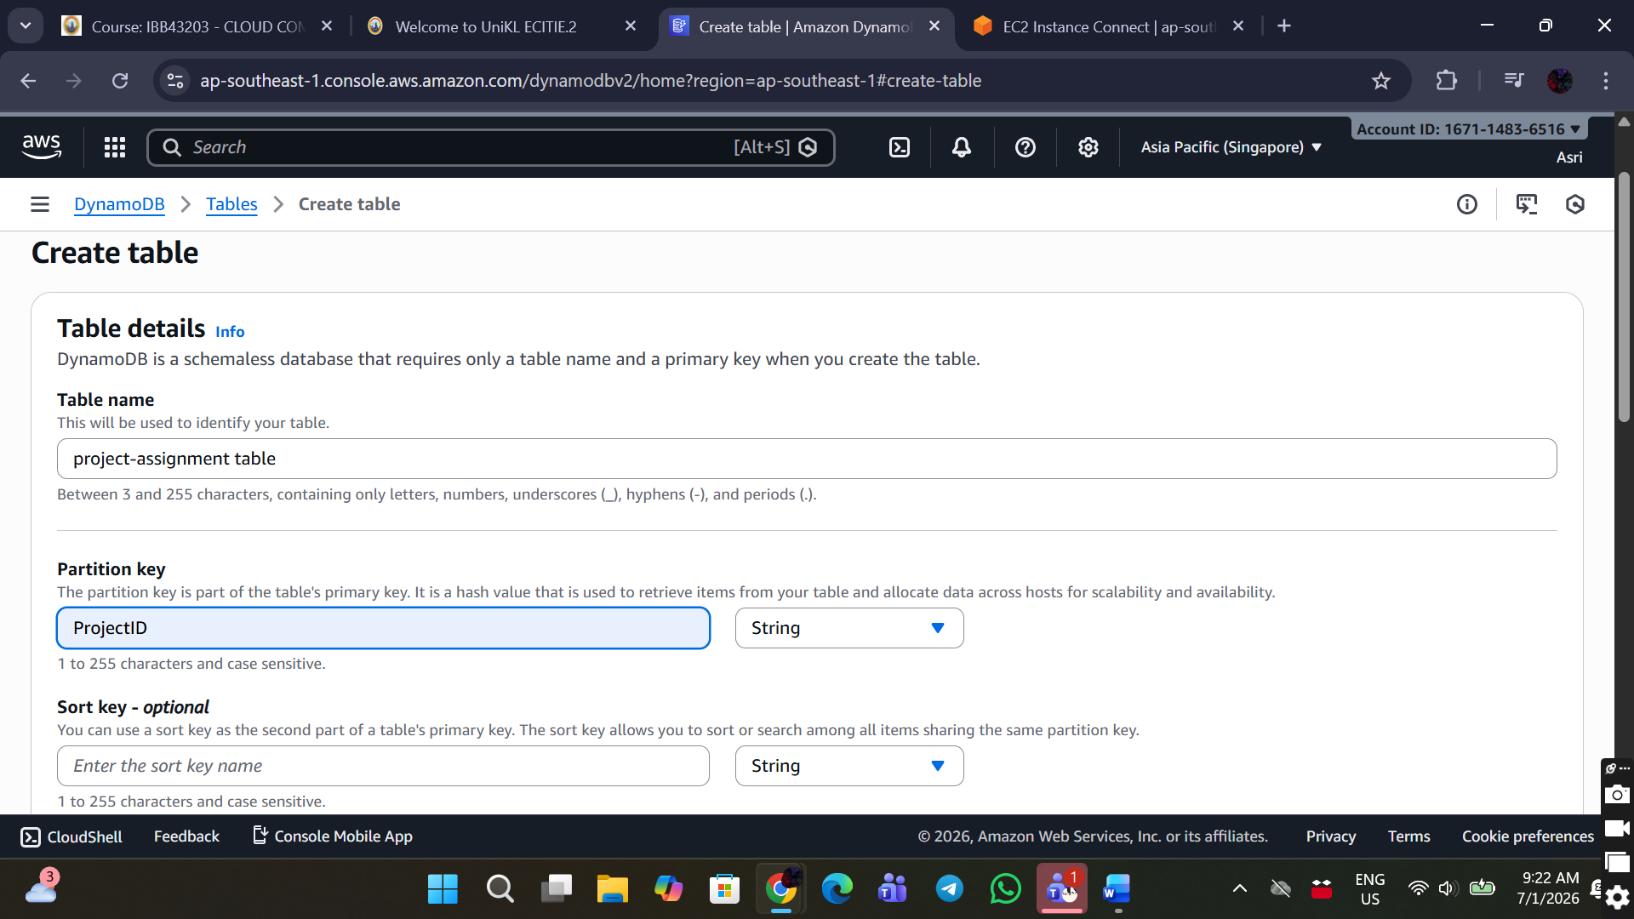

* Use Default table settings, make sure Capacity mode is On-demand.

1. Click Create table
2. Wait until status is Active

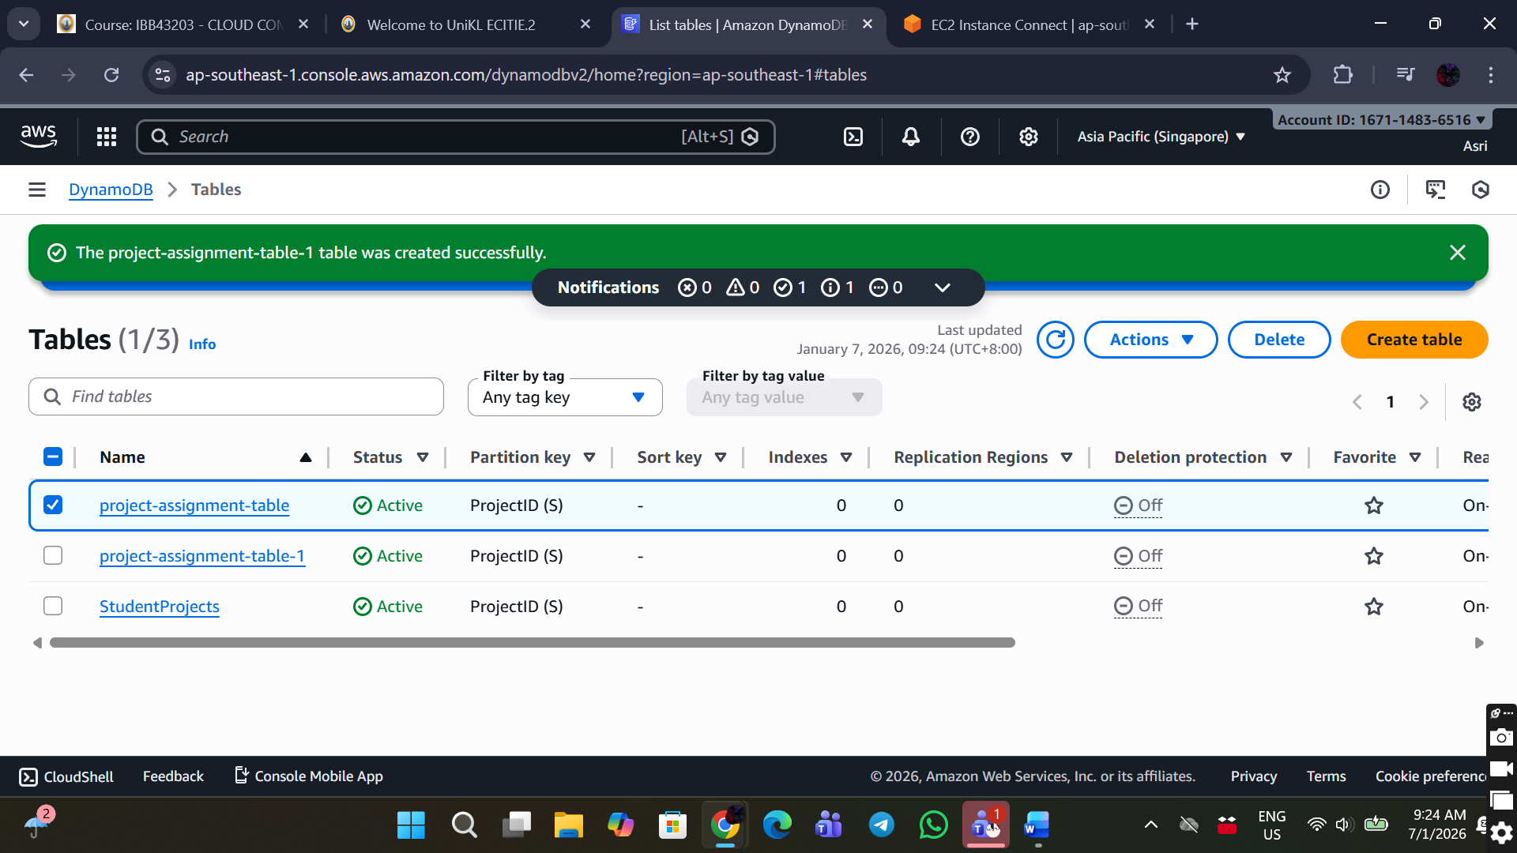

## STEP 5: Create and Attach IAM Role

This allows EC2 to securely access DynamoDB and S3.

1. Create IAM Role. Search and open IAM

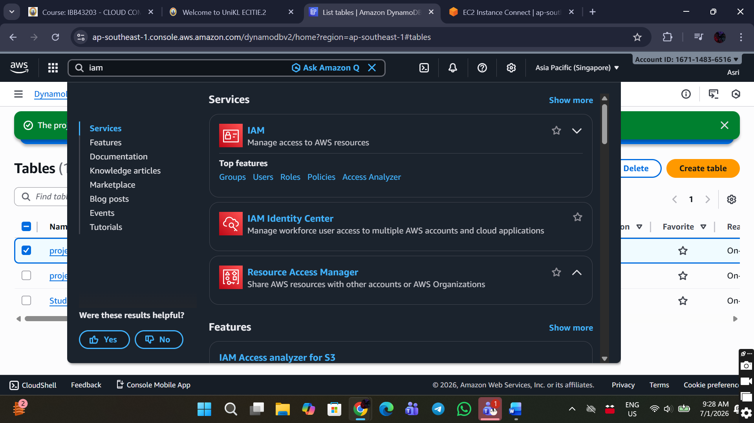

1. Go to Roles → Create role

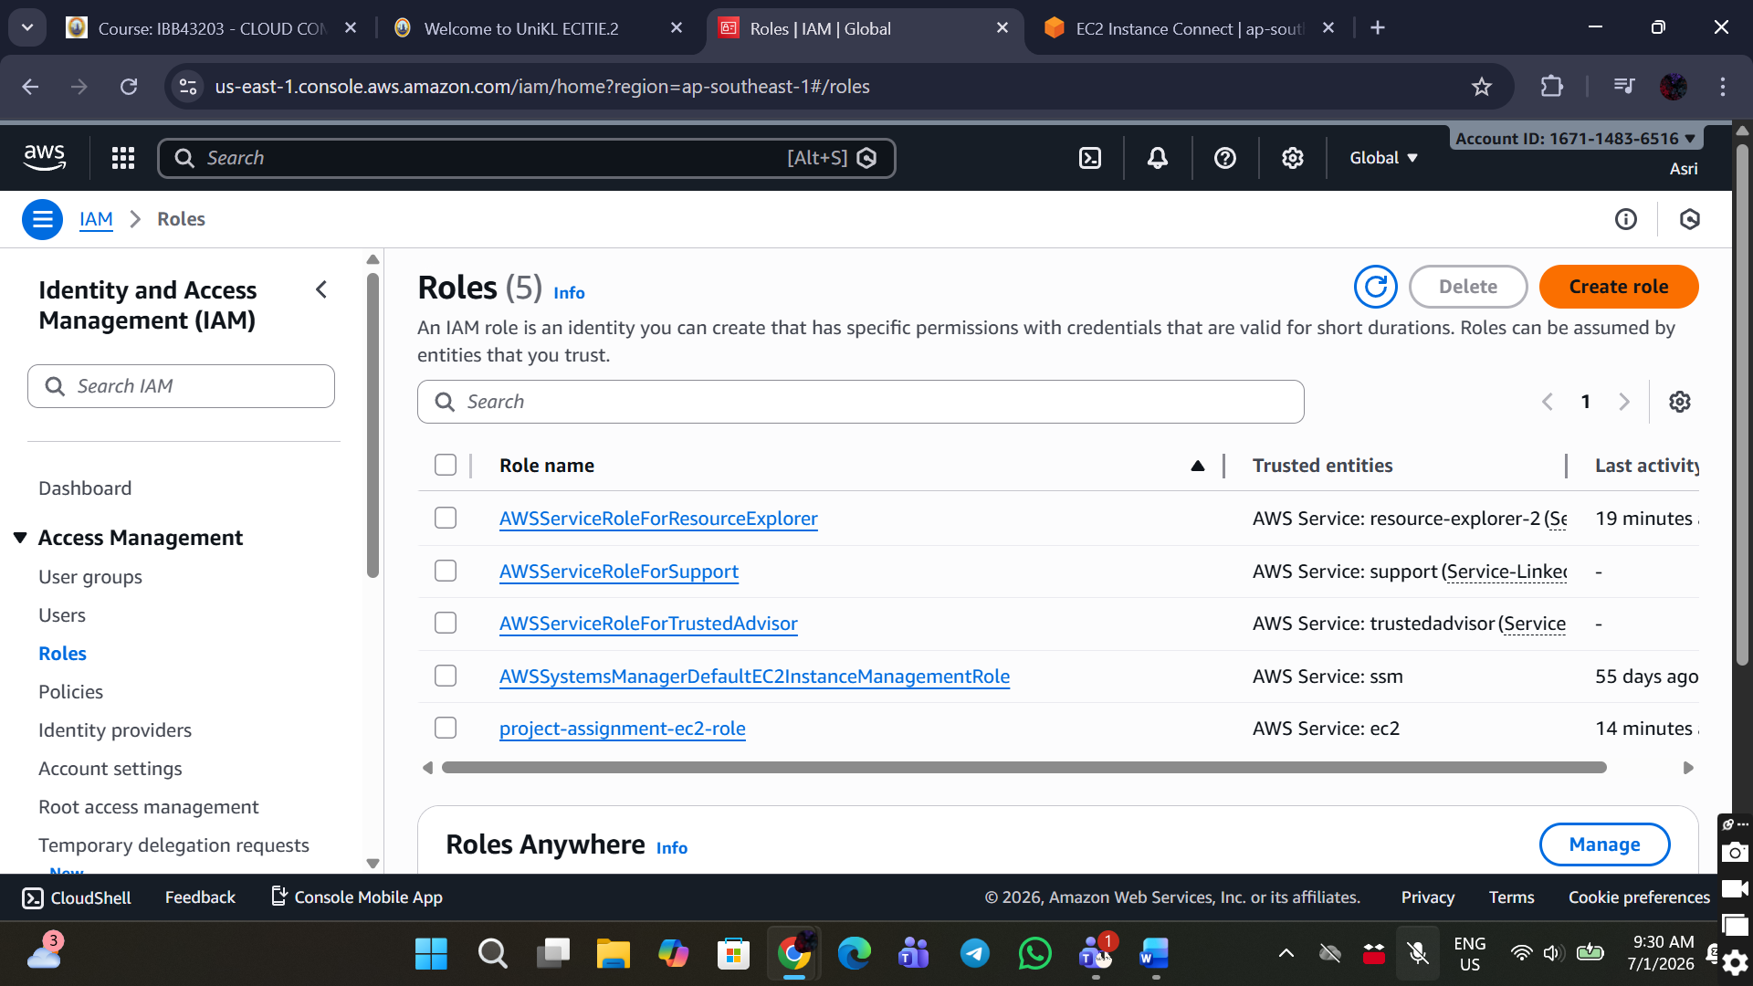

1. Select:

* Trusted entity: AWS service
* Use case: EC2, Allows EC2 instances to call AWS services on your behalf.

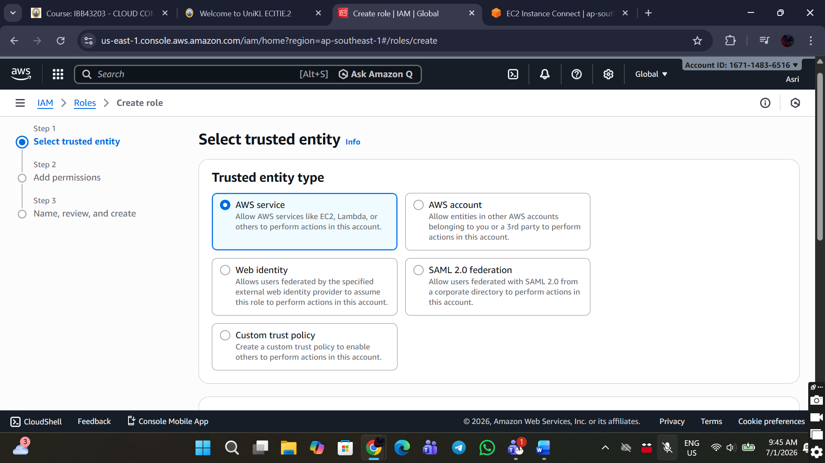

1. Add permissions. Attach Policies

Attach:

* AmazonDynamoDBFullAccess
* AmazonS3FullAccess

1. Role Details

* Role name: project-assignment-ec2-role
* Click Create role

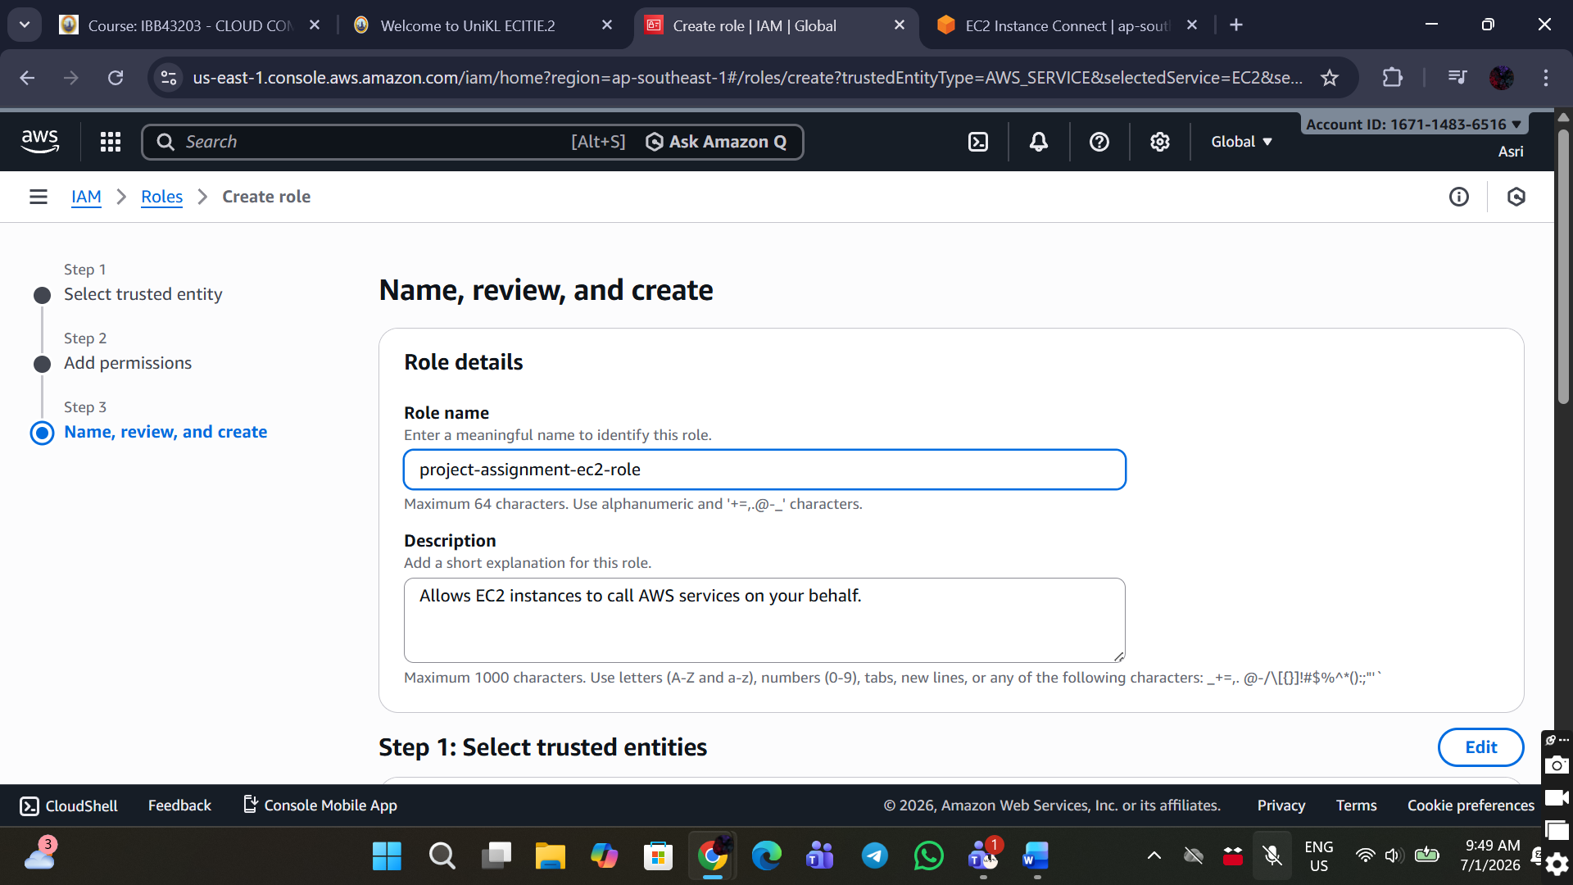

1. Attach Role to EC2

* Go to EC2 → Instances
* Select project-assignment-ec2
* Click Actions → Security → Modify IAM role

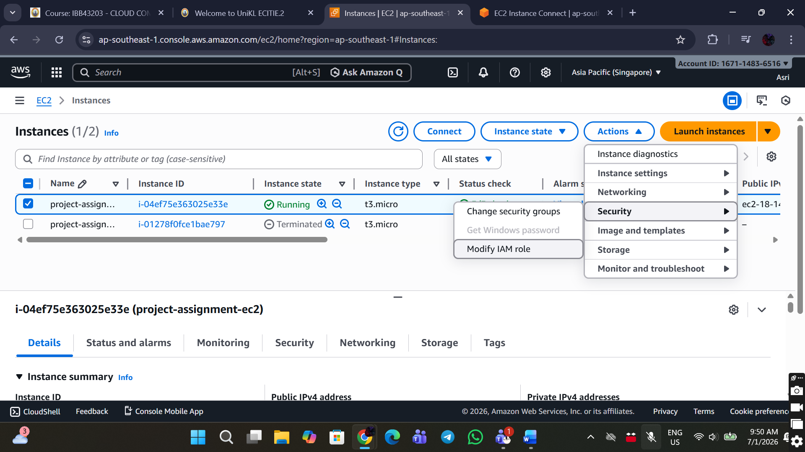

* Select project-assignment-ec2-role
* Click Update IAM role

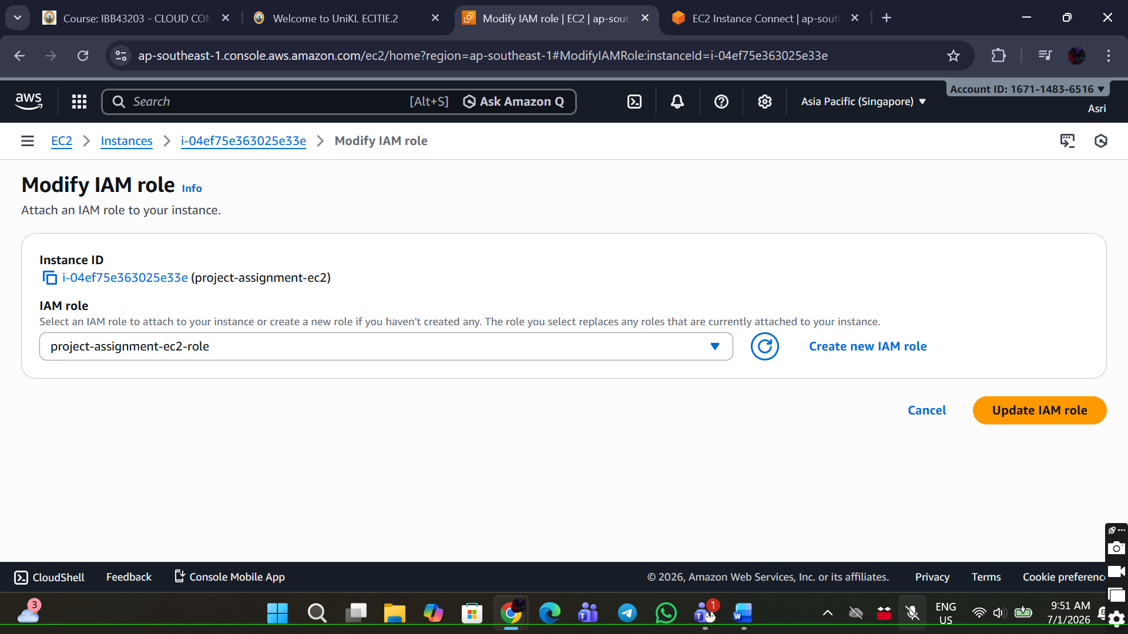

## STEP 6: Networking Configuration

1. Use AWS default networking:

* Default VPC
* Public Subnet
* Internet Gateway
* Security Group

STEP 7: Deploy Website Files

1. Confirm EC2 Status, EC2 status must be Running

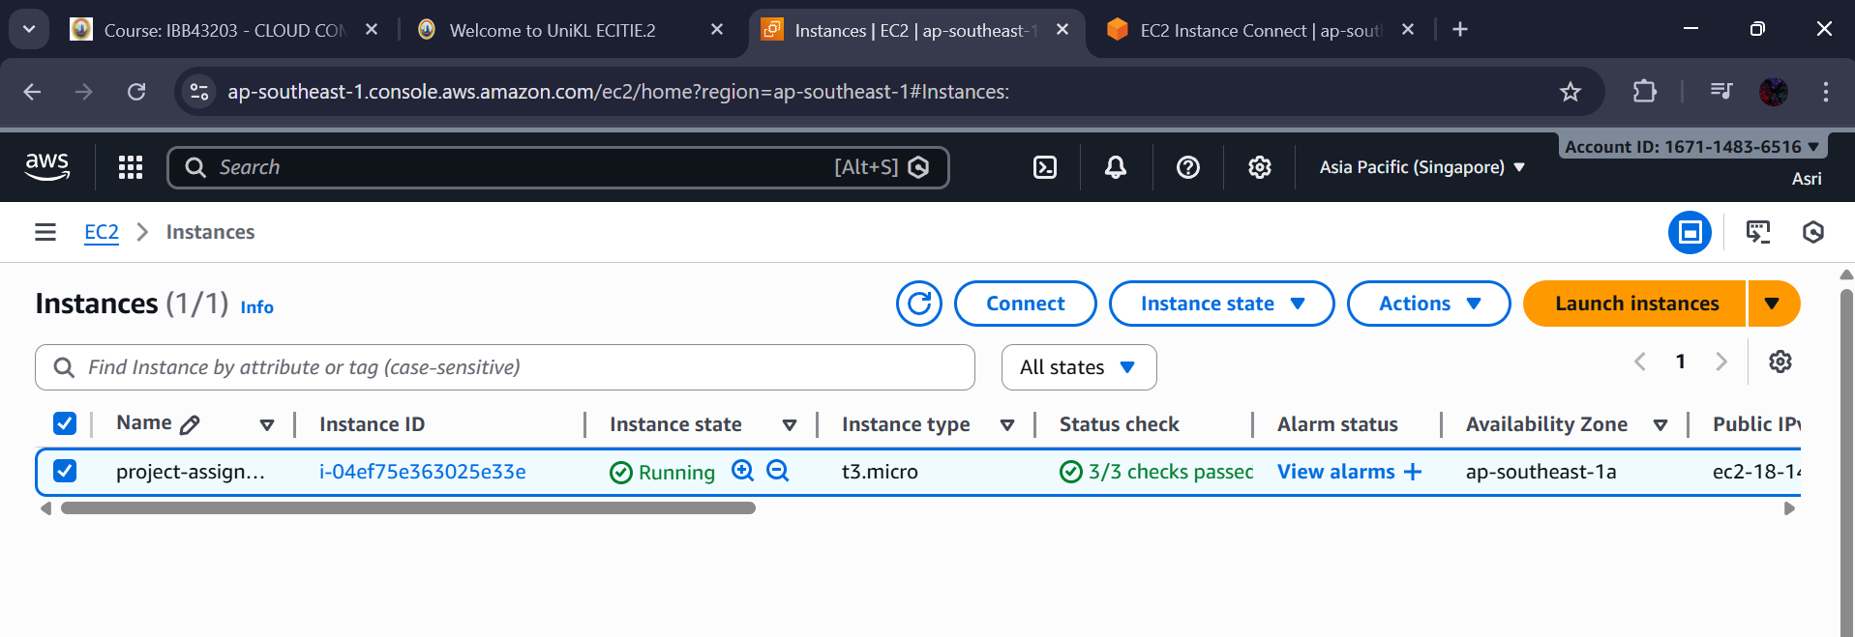

2. Create the index.html, save.php and view.php files. The codes are at the Github repository and APPENDICES section. Paste the codes into the respective files. Press ctrl + O to save the files. Press ctrl + X to exit. Run the following commands:

sudo nano index.html

sudo nano save.php

sudo nano view.php

Website directory for the project is:

/var/www/html/

3. Move files to the website directory

sudo mv index.html save.php view.php /var/www/html/

sudo chown apache:apache /var/www/html/*

## STEP 8: Install AWS SDK for PHP

1. Install Required Packages

sudo yum install php-cli unzip -y

2. Install Composer

cd ~

curl -sS https://getcomposer.org/installer | php

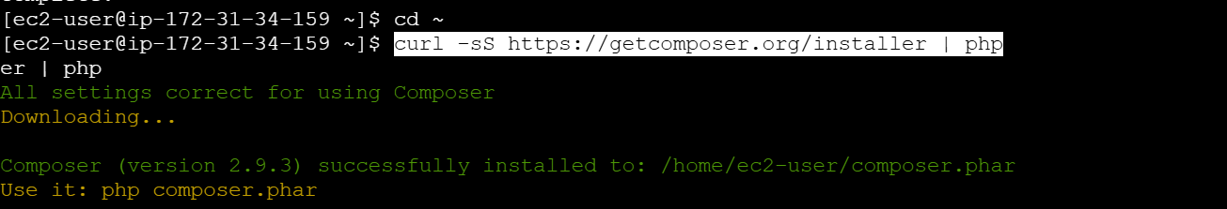

sudo mv composer.phar /usr/local/bin/composer

composer --version

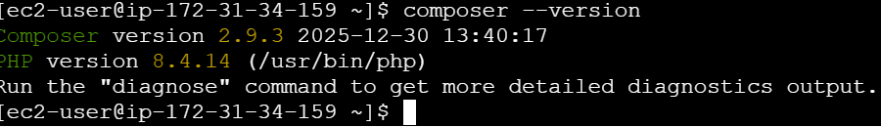

3. Install AWS SDK

cd /var/www/html

composer require aws/aws-sdk-php

4. Restore permissions:

sudo chown -R apache:apache /var/www/html

sudo chmod -R 755 /var/www/html

## STEP 9: Access the Web Application

1. Go to EC2 → Instances
2. Tick the instance and copy Public IPv4 address

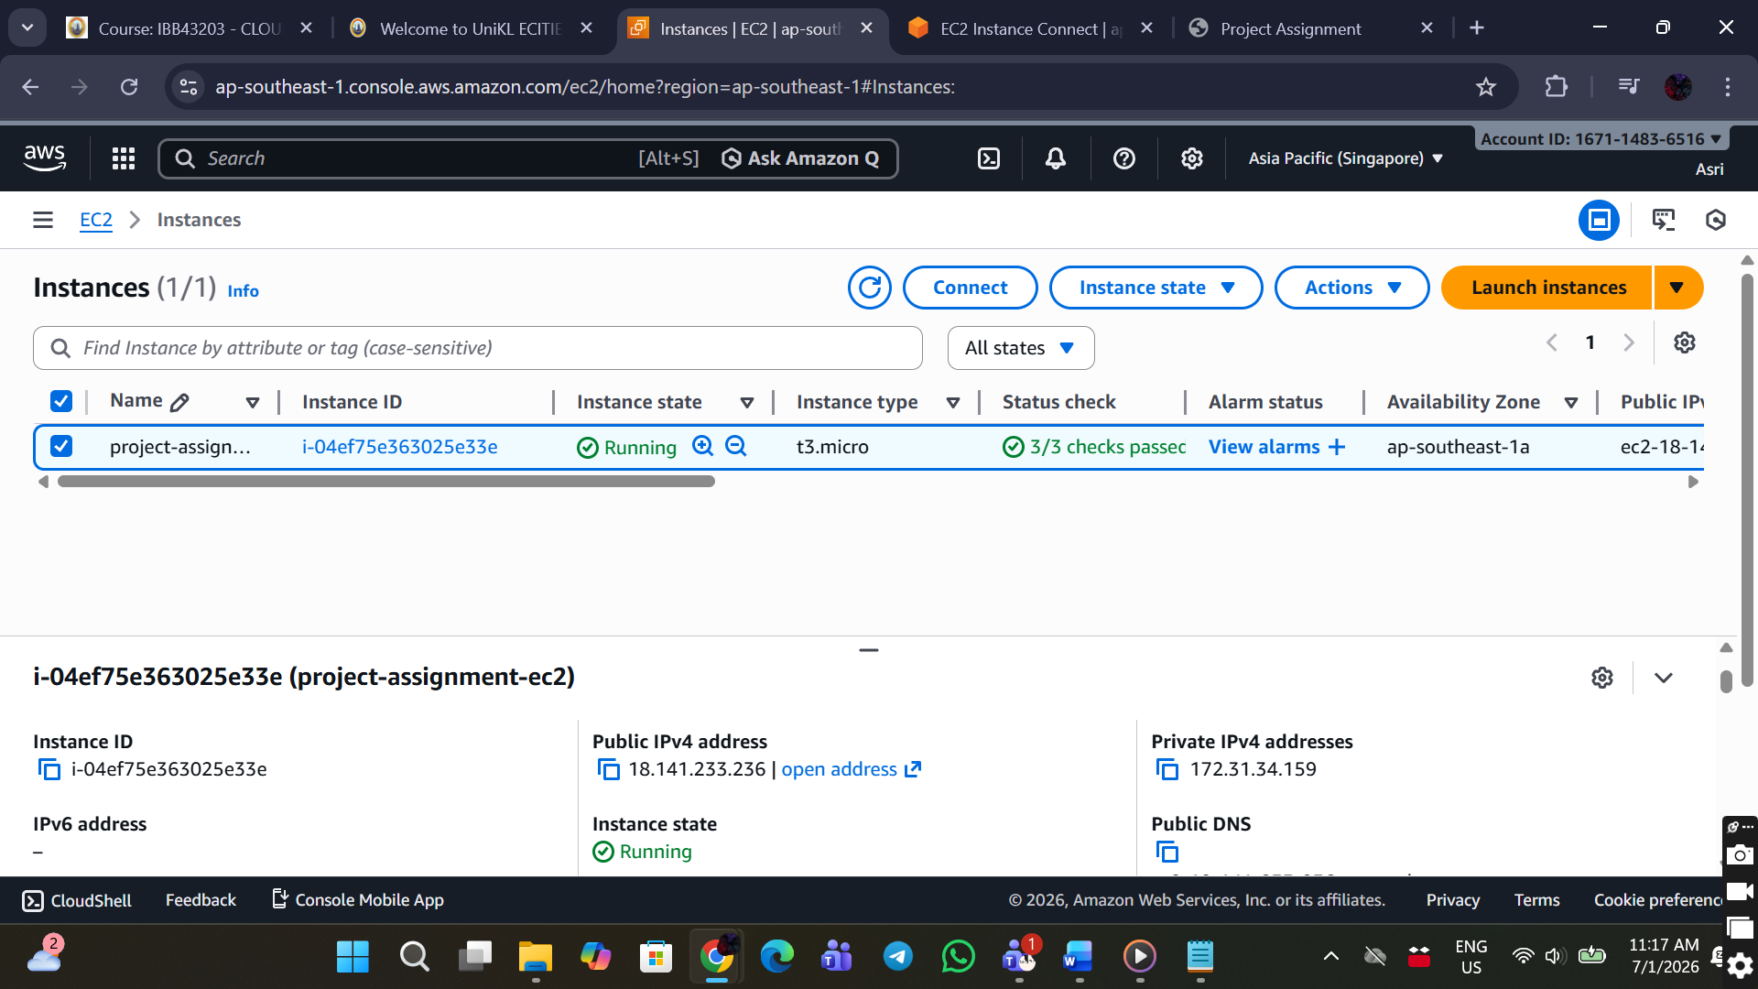

1. Open browser:

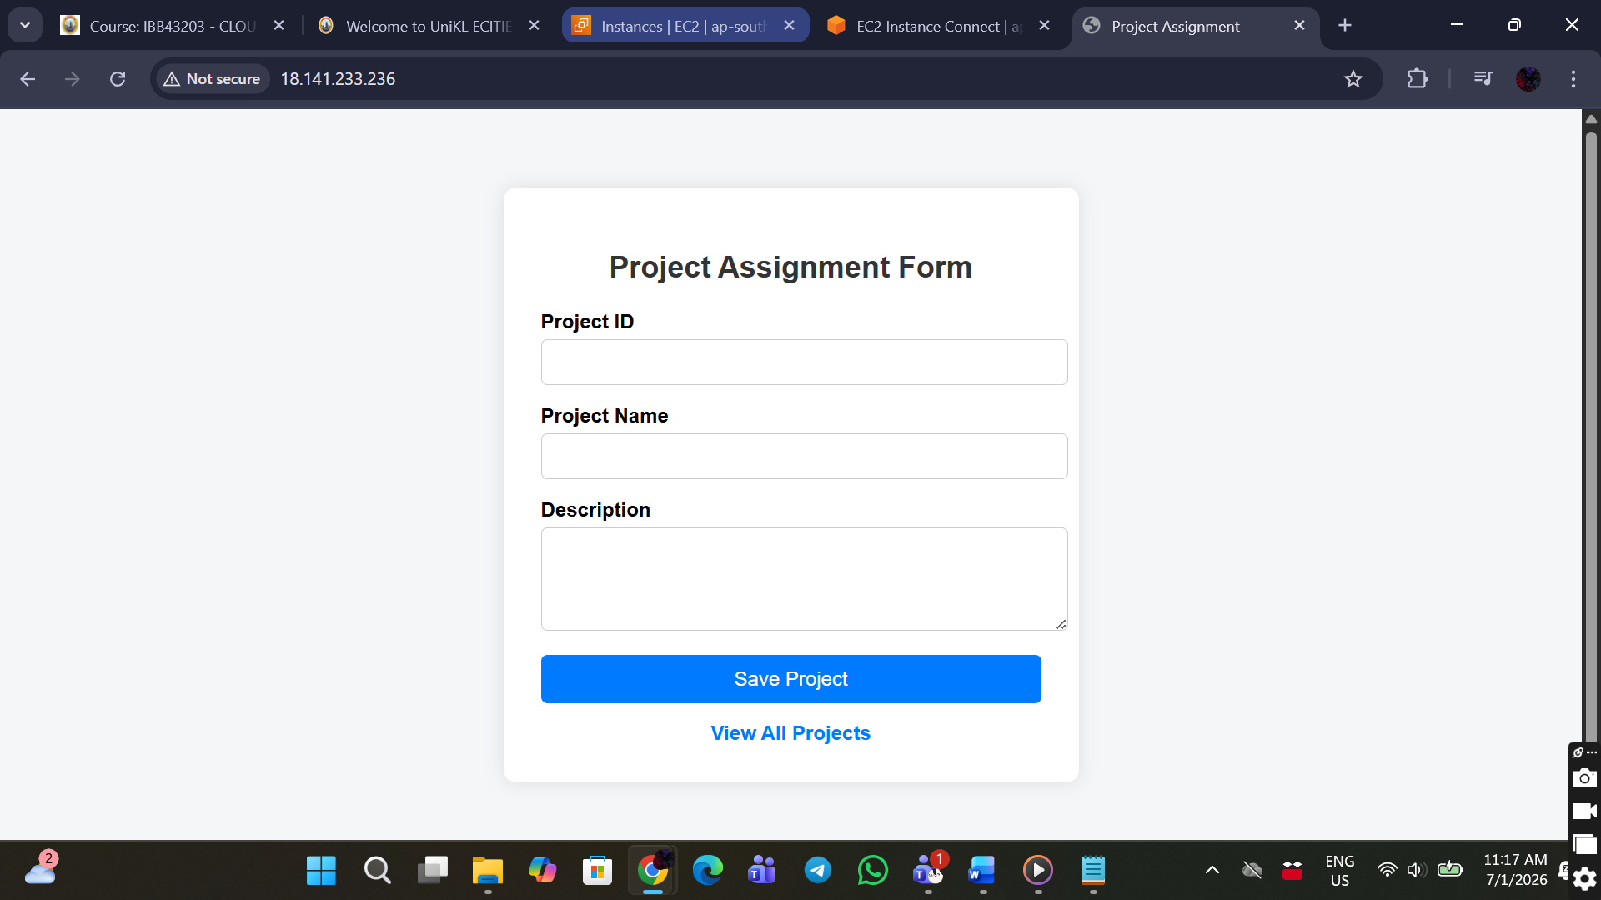

Test the project with project ID, name and description.

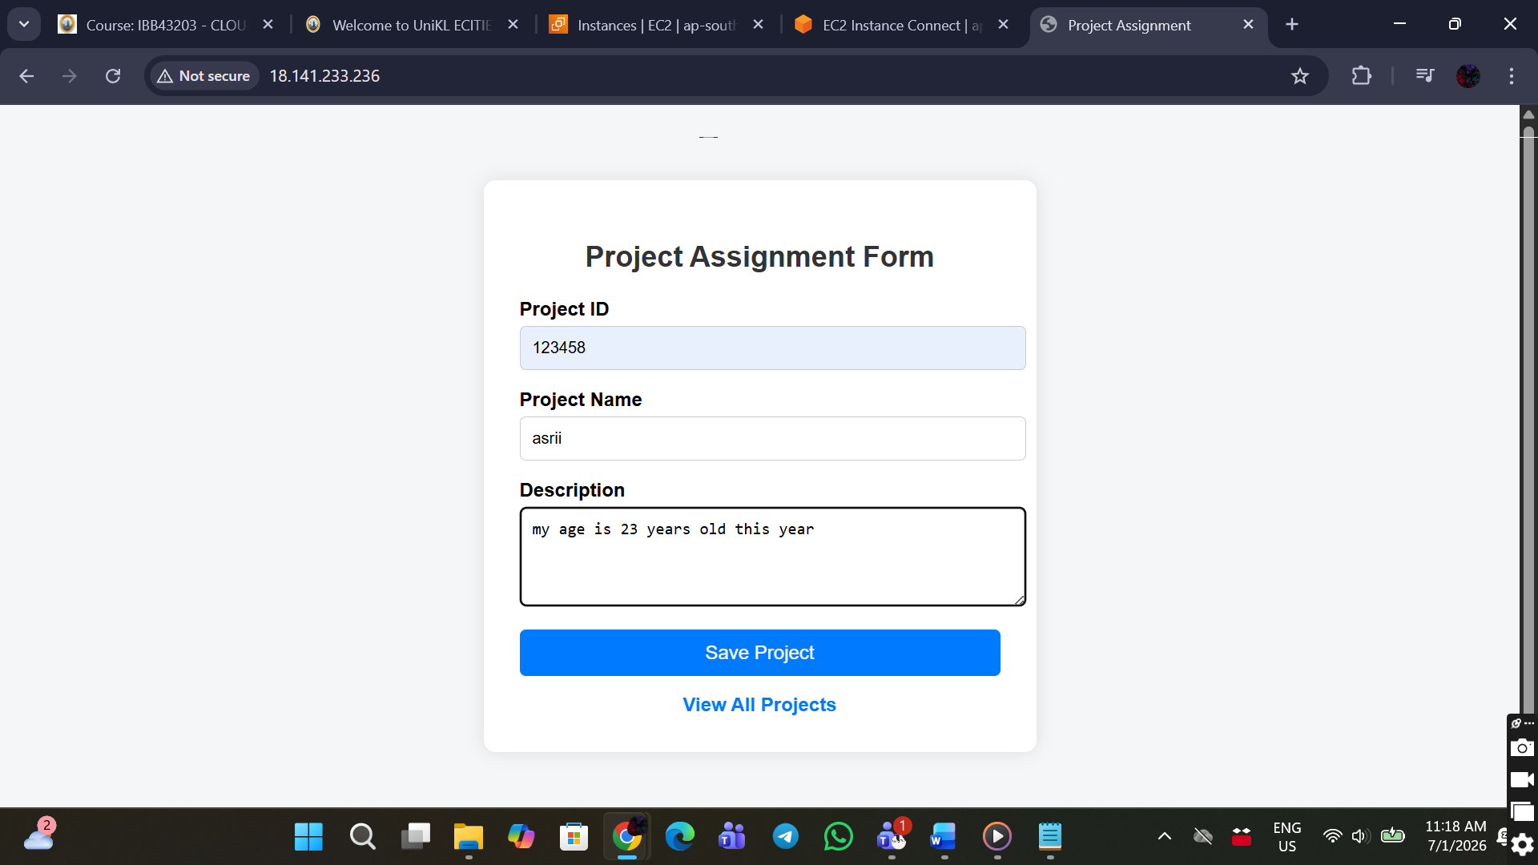

save.php page where it displays the project is saved successfully

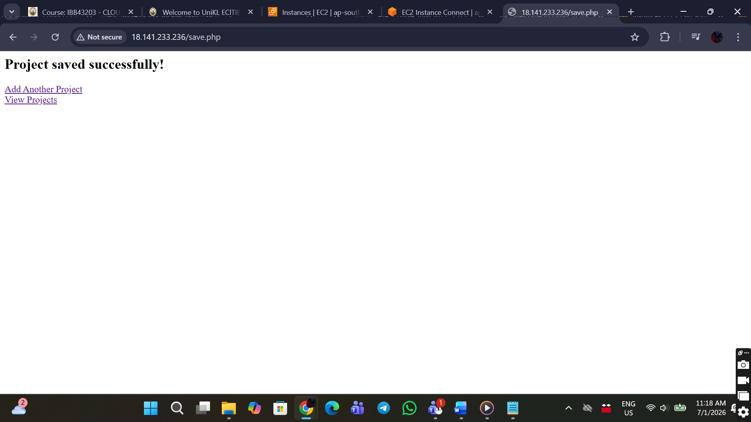

view.php page where it shows the saved projects

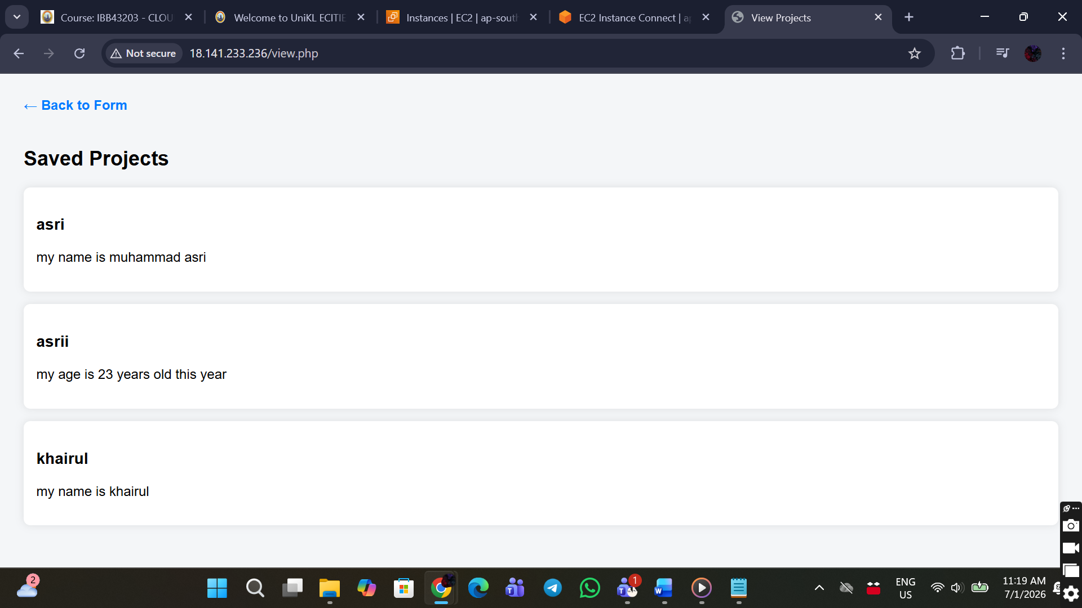

## STEP 10: Verify Data in DynamoDB

1. Open DynamoDB
2. Click Tables
3. Select project-assignment-table
4. Click Explore table items
5. Click Scan

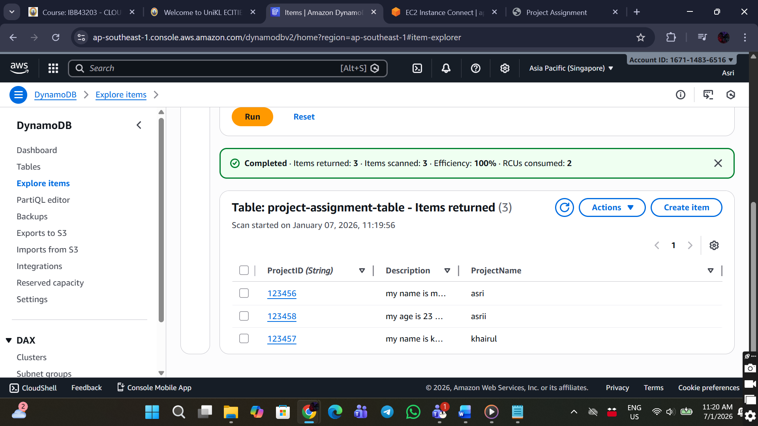

# RESULTS AND DISCUSSION

The web application was successfully deployed and accessed via the public IP address of the EC2 instance. Data submitted through the web form was correctly stored and retrieved from DynamoDB. The use of IAM roles ensured secure access without embedding AWS credentials in the code. All components operated within the AWS Free Tier limits.

# TEAM CONTRIBUTION

This project was developed collaboratively by all team members. Each member worked together throughout the planning, development, and testing phases to ensure the system was successfully deployed. Although the project was completed as a team, each member was assigned specific focus areas based on their roles and responsibilities.

Nur Munawwarah Binti Muzamil focused on the setup of the EC2 instance, networking configuration, and DynamoDB configuration. These tasks ensured that the cloud infrastructure and database services were properly created and accessible.

Muhamad Khairul Ikhwan Bin Samsudin was responsible for IAM configuration, web application development, and coding. This role ensured secure access between AWS services and the correct implementation of application functionality.

Muhammad Asri Bin Azizan contributed to coding, system testing, documentation, and GitHub management. This included verifying system functionality, preparing the project report, and managing version control to support team collaboration.

# CONCLUSION

This project successfully demonstrates the deployment of a web application using AWS cloud services. A secure and scalable solution was achieved by integrating EC2, S3, DynamoDB, IAM, and networking components. The project fulfills all assignment requirements and provides a clear reference for AWS cloud deployment learning.

APPENDICES

<!-- index.html -->

<!DOCTYPE html>

<html lang="en">

<head>

<meta charset="UTF-8">

<title>Project Assignment</title>

<style>

body {

font-family: Arial, sans-serif;

background: #f4f6f8;

display: flex;

justify-content: center;

align-items: center;

height: 100vh;

}

.container {

background: white;

padding: 30px;

width: 400px;

border-radius: 10px;

box-shadow: 0 0 15px rgba(0,0,0,0.1);

}

h2 {

text-align: center;

color: #333;

}

label {

font-weight: bold;

}

input, textarea {

width: 100%;

padding: 10px;

margin-top: 5px;

margin-bottom: 15px;

border: 1px solid #ccc;

border-radius: 5px;

}

button {

width: 100%;

background: #007BFF;

color: white;

padding: 10px;

border: none;

border-radius: 5px;

font-size: 16px;

cursor: pointer;

}

button:hover {

background: #0056b3;

}

.link {

text-align: center;

margin-top: 15px;

}

a {

text-decoration: none;

color: #007BFF;

font-weight: bold;

}

</style>

</head>

<body>

<div class="container">

<h2>Project Assignment Form</h2>

<form action="save.php" method="post">

<label>Project ID</label>

<input type="text" name="id" required>

<label>Project Name</label>

<input type="text" name="name" required>

<label>Description</label>

<textarea name="desc" rows="4" required></textarea>

<button type="submit">Save Project</button>

</form>

<div class="link">

<a href="view.php">View All Projects</a>

</div>

</div>

</body>

</html>

// save.php

<?php

ini_set('display_errors', 1);

error_reporting(E_ALL);

require 'vendor/autoload.php';

use Aws\DynamoDb\DynamoDbClient;

if (!isset($_POST['id'], $_POST['name'], $_POST['desc'])) {

die("Invalid input.");

}

$client = new DynamoDbClient([

'region' => 'ap-southeast-1',

'version' => 'latest'

]);

$client->putItem([

'TableName' => 'project-assignment-table',

'Item' => [

'ProjectID' => ['S' => $_POST['id']],

'ProjectName' => ['S' => $_POST['name']],

'Description' => ['S' => $_POST['desc']]

]

]);

echo "<h2>Project saved successfully!</h2>";

echo "<a href='index.html'>Add Another Project</a><br>";

echo "<a href='view.php'>View Projects</a>";

?>

// view.php

<?php

require 'vendor/autoload.php';

use Aws\DynamoDb\DynamoDbClient;

$client = new DynamoDbClient([

'region' => 'ap-southeast-1',

'version' => 'latest'

]);

$result = $client->scan([

'TableName' => 'project-assignment-table'

]);

?>

<!DOCTYPE html>

<html>

<head>

<title>View Projects</title>

<style>

body {

font-family: Arial, sans-serif;

background: #f4f6f8;

padding: 20px;

}

.card {

background: white;

padding: 15px;

margin-bottom: 15px;

border-radius: 8px;

box-shadow: 0 0 10px rgba(0,0,0,0.1);

}

a {

display: inline-block;

margin-bottom: 20px;

text-decoration: none;

font-weight: bold;

color: #007BFF;

}

</style>

</head>

<body>

<a href="index.html">← Back to Form</a>

<h2>Saved Projects</h2>

<?php

if (count($result['Items']) === 0) {

echo "<p>No projects found.</p>";

}

foreach ($result['Items'] as $item) {

echo "<div class='card'>";

echo "<h3>" . $item['ProjectName']['S'] . "</h3>";

echo "<p>" . $item['Description']['S'] . "</p>";

echo "</div>";

}

?>

</body>

</html>